Overview

NOTE. Do this homework on your hard drive. Do not upload to 000webhost. For some reason, this assignment causes webhost to update its hit counter on the site excessively, which can cause your account to be put to sleep. Upload the code to Canvas when done.

This homework will talk about graphic and animation manipulation in Javascript. We will be building a game similar to, but not identical to Space Invaders. You will do the following:

- Set up the game
- Make the UFOs move
- Make the UFO explode
- Make the ship move
- Make the ship fire missiles
- Finish the game

Exercise 1: Explore Created Form

Create a new html file called mygame.htm- we won’t be doing anything in PHP for this, as we are not doing any database access.

Download the files fighter.png, missile.png, explosion.png and ufo0, ufo1, and ufo2.png. These are the image files for our game. Also download explosion.mp3 and whoosh.mp3. Those will be the sound effects for the game.

In our game, we are going to have a set of UFOs flying around on the top of the screen. The fighter airplane (the player) will be at the bottom of the screen. The fighter airplane will shoot missiles at the UFOs.

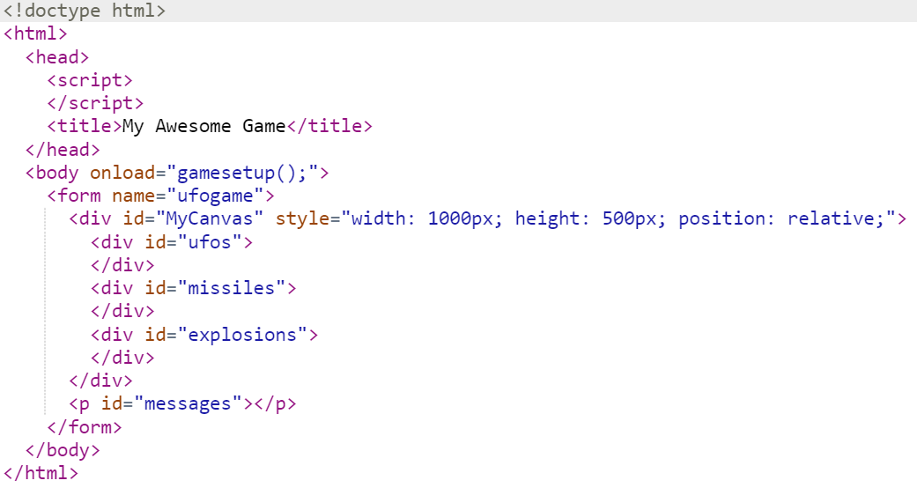
The game itself will be played in a particular section of the screen which we will call the canvas (MyCanvas).

Let’s set up a couple of UFOs and a couple of missiles.

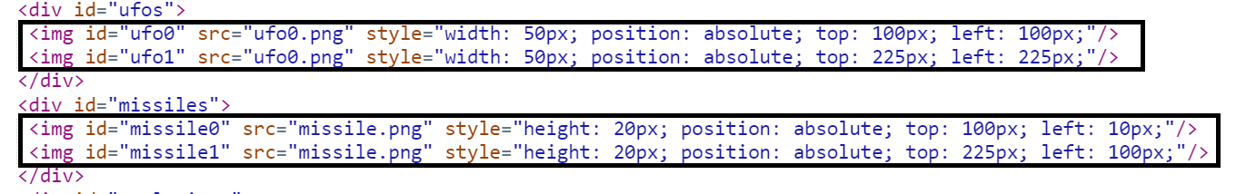So far, a pretty boring screen.
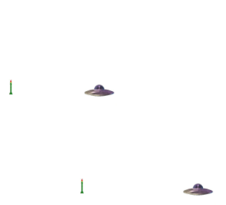

Let’s animate the UFOs. We’re going to make a glowing light appear at the bottom of each UFO. The light will be formed by cycling through the images ufo0 to ufo2. We will cycle up to UFO2 and then cycle back down to UFO0. This will be an infinite animation, i.e., an animation that will never stop. We define such animations in two parts. First, we define the animation function- this is the set of instructions that creates each movement of the animation. We then define how much time passes between each movement of the animation. Create the function below:

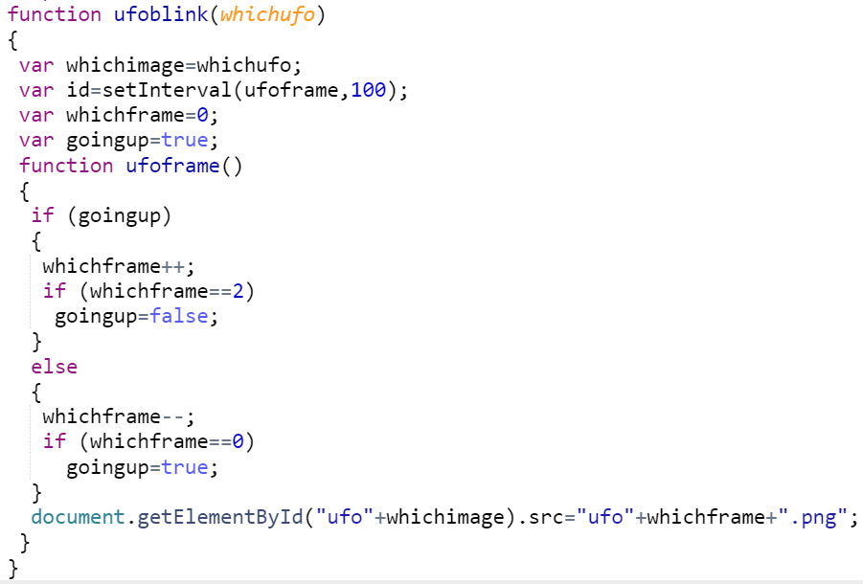

The animation function is ufoframe(). In this function, we increment from 0 to 2, loading the corresponding ufo png into the image. Once we hit 2, we decrement from 2 to 0, again loading the corresponding ufo png. Once we hit 0, we repeat.

The command var id=setInterval(ufoframe, 100) says we will run ufoframe every 1/10th of a millisecond (1000 is one millisecond).

We want this animation generic to be able to link it to all our ufos.

Link the function to the two ufos we have by creating a function called gamesetup(), which is linked to the form’s onload command.

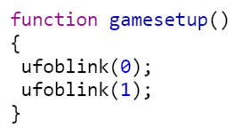
Now run the form and notice how the UFOs now have this blinking thing on the bottom.

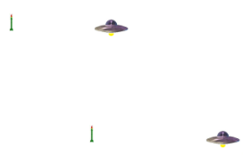

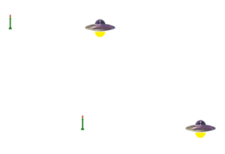

We want this animation to die when the UFO dies. First, we need to track whether the UFO is alive. Add living information about the UFOs to the UFO div.

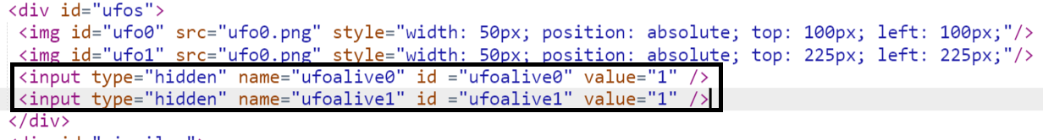
Then add that the animation will stop if the UFO is dead.

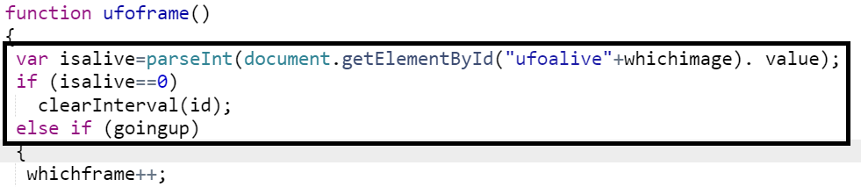
Let’s test this. Make a button called “killufo1”

And create the function to kill the UFO

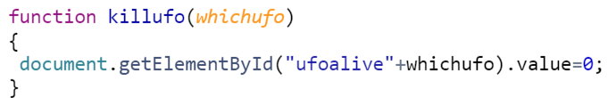
Press the button and notice how UFO 1 stops animating, but UFO0 does not.

Exercise 2: Make UFOs Move

We also want our UFOs to move. To get UFOs to move, we are going to have to store where they are on the screen. Add the following to the HTML:

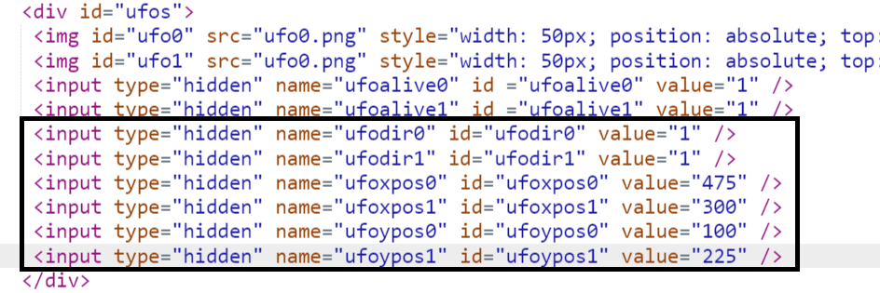
Ufodir will be the direction (1=to the right, 0=to the left) the UFO will move. Ufoxpos and ufoypos are the actual coordinates of the UFO. Now, we can create the UFO movement animation.
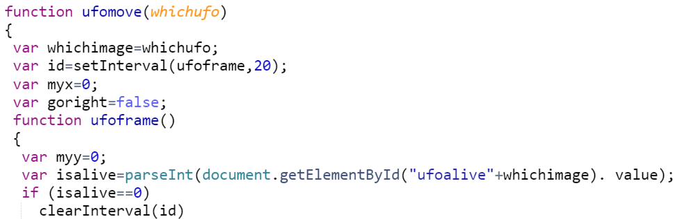
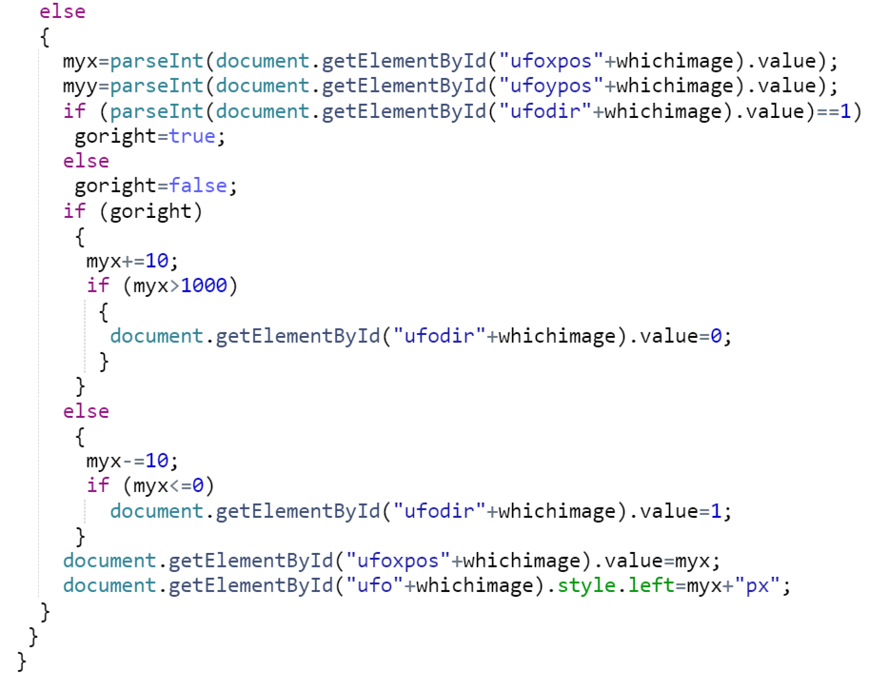

Then link this to the game setup.

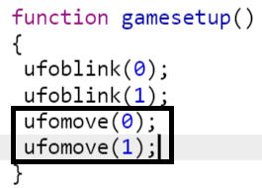

We now have moving UFOs. Furthermore, when the UFOs are killed, the animations stop (press the Kill UFO 1 button to see this).

Exercise 3: Make UFOs Explode

But, those UFOs need to blow up when they die. First, we need to create explosions.

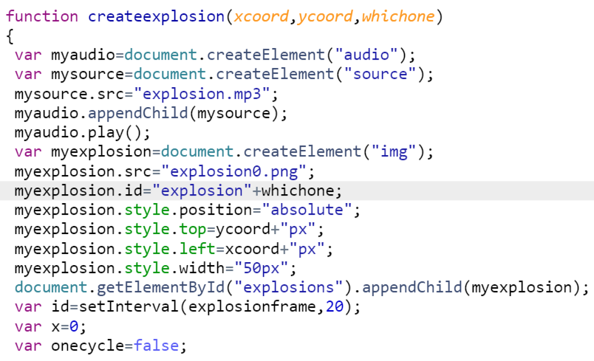
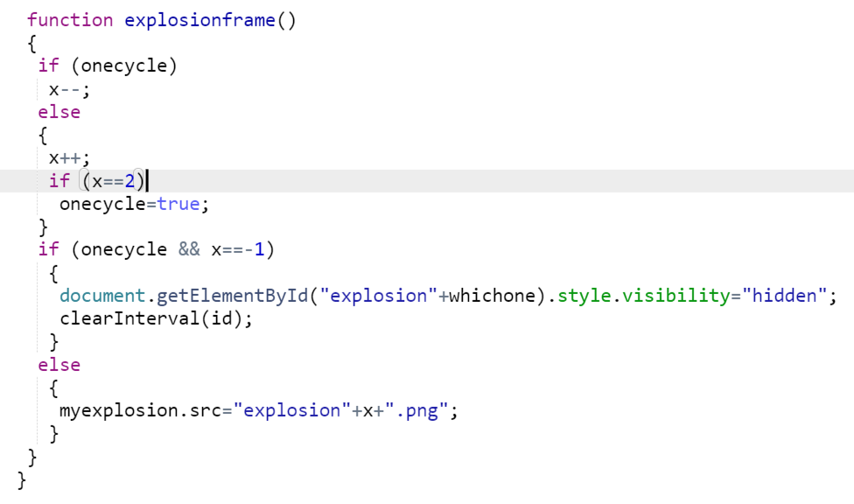

Then, we need to link the explosion to killufo and hide the killed ufo.

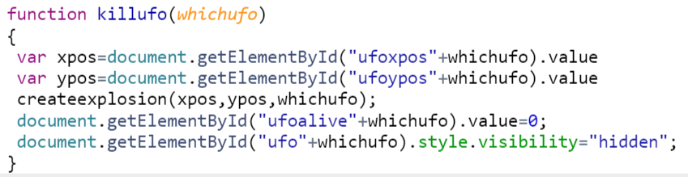

Of course, we don’t want to kill UFOs with buttons. We want to kill them when they hit the missiles. In order to test for collision with missiles, we need to know where the missiles are, and how many of them are there. Add the following to the HTML.

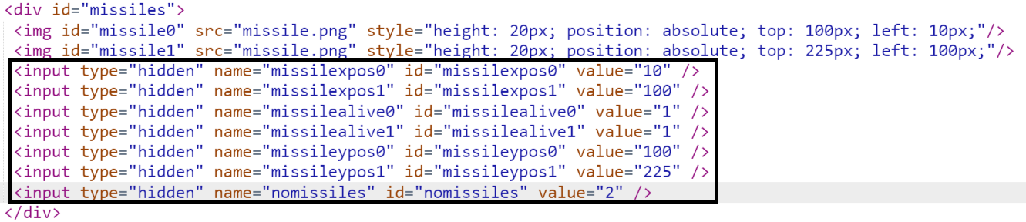
Then add the following lines to ufomove

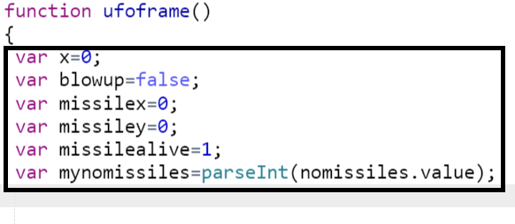
.
.
.
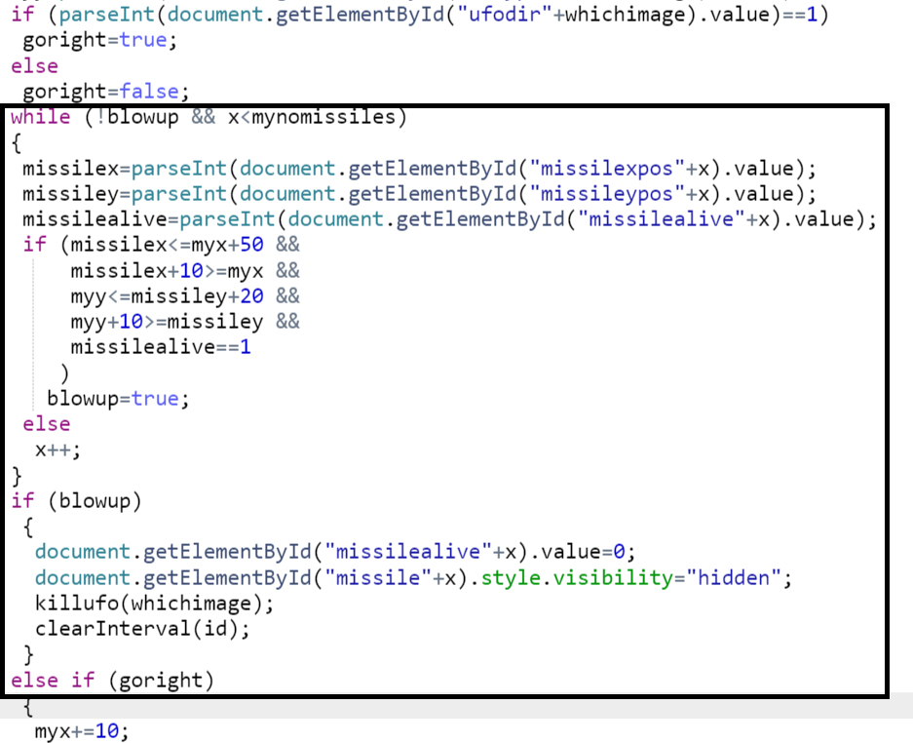

Observe how the UFOs blow up when they hit the (currently not moving) missiles.
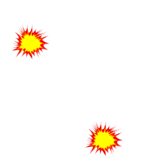

Exercise 4: Make Fighter Move

The fighter plane is different from the UFOs in that it is human controlled. So, the animations for the fighter plane will be based on what the human is doing. The fighter will move based on the last key the human created. First, let’s cause the fighter plane to show up on screen. Add the following code:

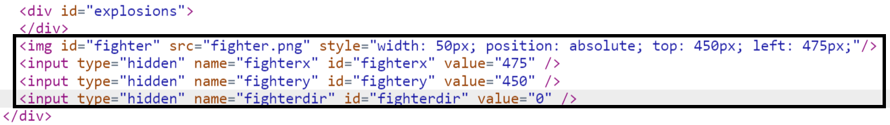
The fighter animation is similar to the UFO one.

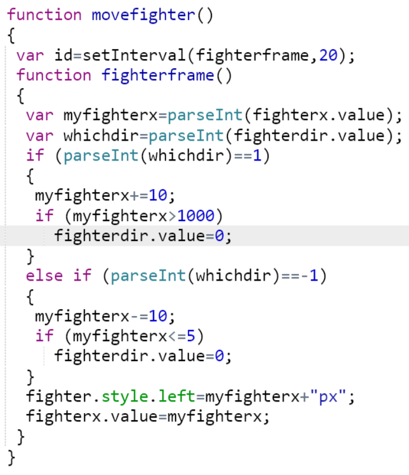
Add movefighter() to gamesetup().

We also now create a new function that manages user keyboard entry:

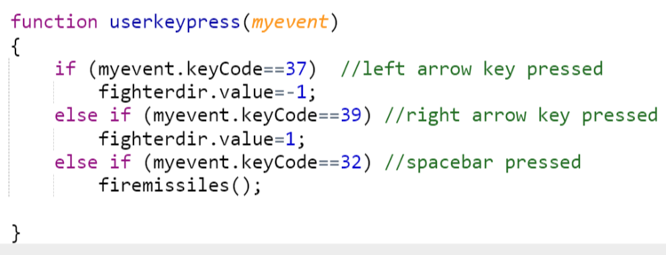
If the user hits the left arrow key, the fighter moves left. If the user hits the right arrow key, it moves right.

We link the userkeypress function to the keypress event.

Now try the screen. Press the left and right arrow keys.

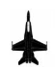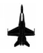

The problem with our game is it is not supported on mobile devices. Let’s fix this. Create an interface for mobile devices too.

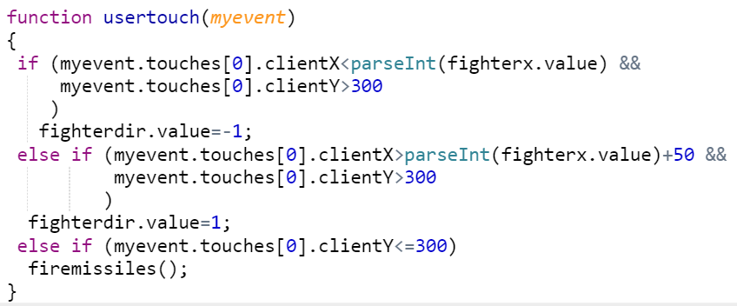
Link that interface to the ontouchstart event:

Try the game on your mobile device. Touch to the left of the fighter to move left, and to the right of the fighter to move right.

Exercise 5: Fire Missiles

Missiles start moving from the middle of the fighter.

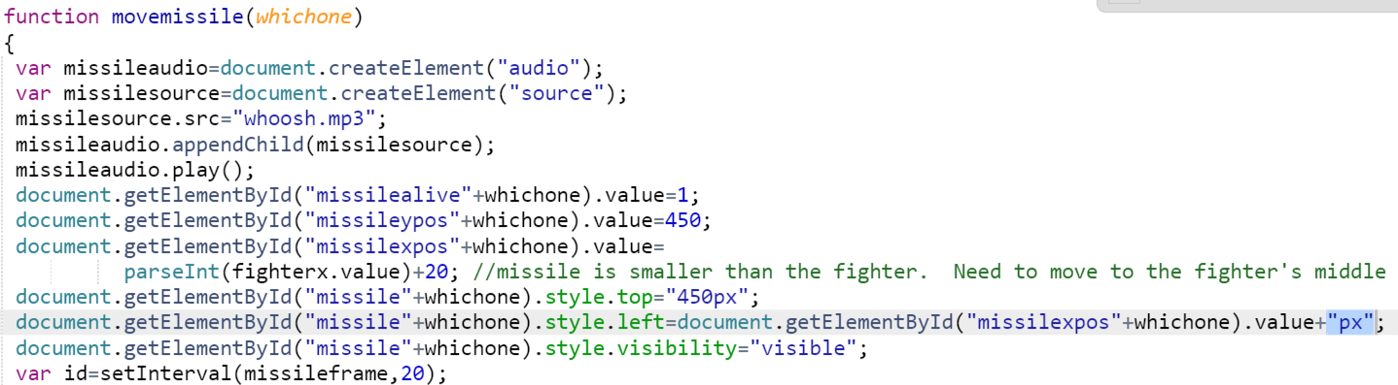
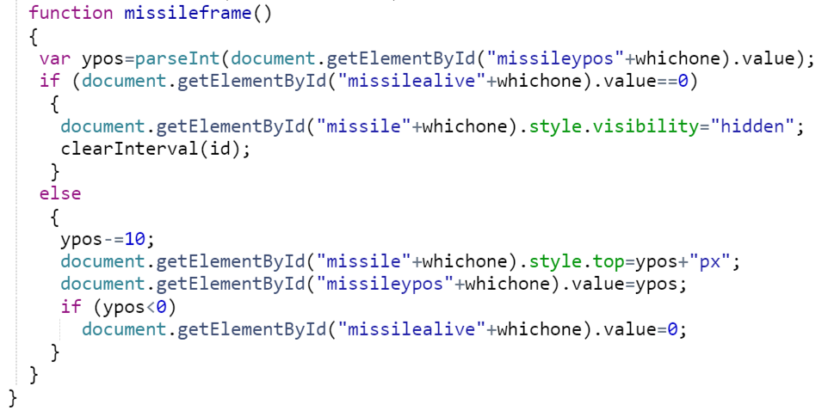

We can only have a certain number of missiles on the screen at a time. We fire them with the space bar.

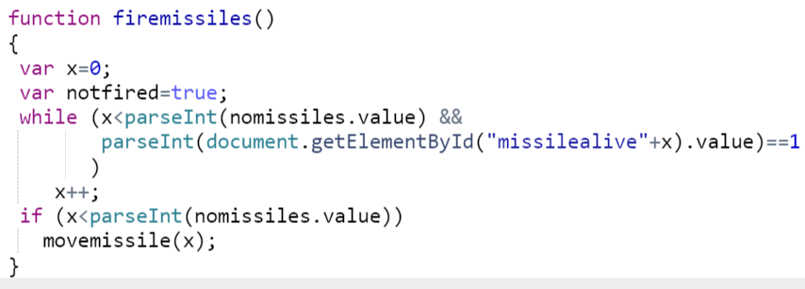Exercise 6: Finishing the Game

Now that we have all the basic game ingredients set up, we now have to set the game itself up. We want an increasing number of UFOs (starting at 10), and four missiles. Clear off all the information in the UFOs and missiles divs. Your revised form should look like this:

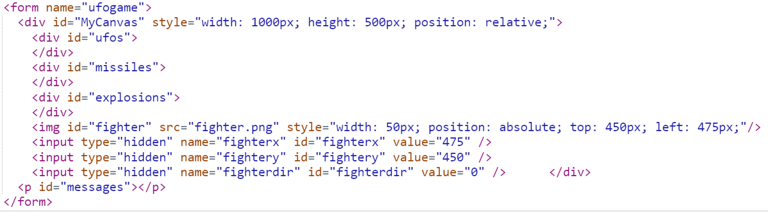
Also, get rid of the killufo(1) button.

Then, modify gamesetup as follows:

function gamesetup(nobadguys,nomissiles)
{
var x=0;
var myhidden;
document.getElementById("ufos").innerHTML="";
document.getElementById("missiles").innerHTML="";
document.getElementById("explosions").innerHTML="";
for (x=0; x<nobadguys; x++)
{
myhidden=document.createElement("input");
myhidden.type="hidden"
myhidden.name="ufoalive"+x;
myhidden.id="ufoalive"+x;
myhidden.value=1;
document.getElementById("ufos").appendChild(myhidden);
myhidden=document.createElement("input");
myhidden.type="hidden"
myhidden.name="ufodir"+x;
myhidden.id="ufodir"+x;
myhidden.value=Math.floor((Math.random() * 2)); //Random either left or right
document.getElementById("ufos").appendChild(myhidden);
myhidden=document.createElement("input");
myhidden.type="hidden"
myhidden.name="ufoxpos"+x;
myhidden.id="ufoxpos"+x;
myhidden.value=Math.floor((Math.random() * 500)); //Any X coordinate on the screen
document.getElementById("ufos").appendChild(myhidden);
myhidden=document.createElement("input");
myhidden.type="hidden"
myhidden.name="ufoypos"+x;
myhidden.id="ufoypos"+x;
myhidden.value=Math.floor((Math.random() * 300)); //Any Y coordinate on the top 3/5ths of the screen
document.getElementById("ufos").appendChild(myhidden);
myhidden=document.createElement("img");
myhidden.src="ufo0.png"
myhidden.id="ufo"+x;
myhidden.style.width="50px";
myhidden.style.position="absolute";
myhidden.style.top=document.getElementById("ufoypos"+x).value+”px”;
myhidden.style.left=document.getElementById("ufoxpos"+x).value+”px”;
document.getElementById("ufos").appendChild(myhidden);
ufoblink(x);
ufomove(x);
}
myhidden=document.createElement("input");
myhidden.type="hidden"
myhidden.name="noufos";
myhidden.id="noufos";
myhidden.value=x;
ufos.appendChild(myhidden);
myhidden=document.createElement("input");
myhidden.type="hidden"
myhidden.name="noufosleft";
myhidden.id="noufosleft";
myhidden.value=x;
ufos.appendChild(myhidden);
for (x=0; x<nomissiles; x++)
{
myhidden=document.createElement("input");
myhidden.type="hidden"
myhidden.name="missilexpos"+x;
myhidden.id="missilexpos"+x;
myhidden.value=0; //Doesn't matter. Will be reset by the space bar.
missiles.appendChild(myhidden);
myhidden=document.createElement("input");
myhidden.type="hidden";
myhidden.name="missileypos"+x;
myhidden.id="missileypos"+x;
myhidden.value=450; //Doesn't matter. Will be reset by the space bar.
missiles.appendChild(myhidden);
myhidden=document.createElement("input");
myhidden.type="hidden";
myhidden.name="missilealive"+x;
myhidden.id="missilealive"+x;
myhidden.value=0; //Missile ready to fire.
missiles.appendChild(myhidden);
myhidden=document.createElement("img");
myhidden.src="missile.png"
myhidden.id="missile"+x;
myhidden.style.height="20px";
myhidden.style.position="absolute";
myhidden.style.top=document.getElementById("missileypos"+x).value+”px”;
myhidden.style.left=document.getElementById("missilexpos"+x).value+”px”;
myhidden.style.visibility="hidden";
missiles.appendChild(myhidden);
}
myhidden=document.createElement("input");
myhidden.type="hidden"
myhidden.name="nomissiles";
myhidden.id="nomissiles";
myhidden.value=nomissiles;
missiles.appendChild(myhidden);
messages.innerHTML="Level: "+
(nobadguys-9)+
"<br /> Total bad guys: "+
nobadguys+
"<br /> No remaining: "
+nobadguys;
movefighter();
}

All this does is set up the game by generating a bunch of UFOs and missiles.

Modify the body as follows:

If you run it now, the game will be able to play the first level.

But we want more levels, with even more UFOs. Make the following changes to ufomove

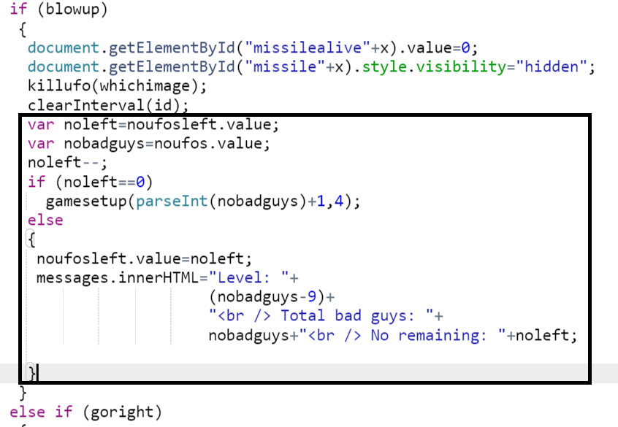

We now have a fully functional game (other than the fact the bad guys don’t fight back).

